**ANALYSIS OF COVID-19 BASED UPON SYMPTOMS**

*A project report submitted in partial fulfillment of the requirements*

*for the award of the degree of*

**MASTER OF COMPUTER APPLICATIONS**

**(CA 656)**

BY

**Meghaj Kumar Mallick(MCA/25017/18)**



**DEPARTMENT OF COMPUTER SCIENCE & ENGINEERING**

**BIRLA INSTITUTE OF TECHNOLOGY, MESRA**

**JAIPUR CAMPUS, JAIPUR**

**SP-2021**

**DECLARATION CERTIFICATE**

This is to certify that the work presented in the project entitled “Analysis of COVID-19 based upon the Symptoms**”** in partial fulfillment of the requirement for the award of Degree of Master of Computer Applications of Birla Institute of Technology, Mesra, Ranchi, Extension Center Jaipur is an authentic work carried out under our supervision and guidance.

To the best of my knowledge, the content of this project does not form a basis for the award of any previous degree to anyone else.

Date:

**Student Name & Roll No : Signature**

**Meghaj Kumar Mallick (MCA/25017/18)**

Name of Supervisor and Signature:

Dr. Madhavi Sinha

Associate Professor & In-charge,

Department of Computer Science & Engineering

Birla Institute of Technology, Mesra, Jaipur Campus

Name of Supervisor and Signature:

Dr. Piyush Gupta

Associate Professor,

Department of Computer Science & Engineering

Birla Institute of Technology, Mesra, Jaipur Campus

ACKNOWLEDGEMENT

I would like to express my special thanks of gratitude to Dr. Piyush Gupta Sir(Project Coordinator) as well as to Dr. Madhavi Sinha Mam (H.O.D Computer Science Department, BIT Mesra, Jaipur Campus) who gave me the golden opportunity to do this wonderful project on the topic” Analysis of COVID-19 based upon the Symptoms”, which also helped me in doing a lot of Research and I came to know about so many new things I am really thankful to them.

Secondly I would also like to thank my parents and friends who helped me a lot in finalizing this project within the limited time frame.

**Meghaj Kumar Mallick (MCA/25017/18)**

INDEX PAGE

|  |  |  |
| --- | --- | --- |
| SR NO | TOPIC | PAGE NO. |
| 1 | ABSTRACT | 6 |
| 2 | INTRODUCTION | 6-7 |
| 3 | MOTIVATION | 7 |
| 4 | AIM | 7 |
| 5 | OBJECTIVE | 8 |
| 6 | SOFTWARE & HARDWARE SOFTWARE REQUIREMENT (SRS) | 8 |
| 7 | SCOPE & FUTURE WORK | 8 |
| 8 | CONTEXT LEVEL DIAGRAM | 9 |
| 8 (A) | DFD LEVEL 0 | 9 |
| 8 (B) | DFD LEVEL 1 | 10 |
| 9 | CLASS DIAGRAM | 11 |
| 10 | NON FUNCTIONAL REQUIRMENT | 11 |
| 11 | THE DATASET (SDS) | 12 |
| 12 | LOADING & CLEANING DATA | 13-14 |
| 13 | DATA PREPROCESSING | 14-15 |
| 14 | MODEL SELECTION | 15 |
| 15 (A) | LOGISTIC REGRESSION ALGORITHM | 15-16 |
| 15 (B) | RANDOM FOREST ALGORITHM | 16-17 |
| 15 (C) | NAIVE BAYES ALGORITHM | 17 |
| 16 | ENSEMBLE TECHNIQUE |  |
| 17 | PREDICTION & IMPLEMENTATION |  |
| A | STEP I: |  |
| B | STEP II: |  |
| C | STEP III: |  |
| D | STEP IV: |  |
| 18 | LIMITATION |  |
| 19 | CONCLUSION |  |
| 20 | REFERENCES |  |

1. **ABSTRACT**

The novel corona virus disease 2019 (COVID-19) pandemic caused by the SARS-CoV-2 continues to pose a critical and urgent threat to global health. This project is based upon the analysis & prediction of the COVID-19 (Corona Virus) disease by their symptoms.

As this COVID-19 is spread from person to person, Artificial intelligence based electronic

devices can play a pivotal role in preventing the spread of this virus. As the role of healthcare epidemiologists has expanded, the pervasiveness of electronic health data has expanded too.

The increasing availability of electronic health data presents a major opportunity in healthcare for both discoveries and practical applications to improve healthcare. This data can be used for training machine learning algorithms to improve its decision-making in terms of predicting diseases.

This project describes the application of machine learning. We will use various machine leaning algorithm such as logistic regression, random forest & naive bayes algorithm

In this process, we propose a machine-learning model that predicts a positive COVID-19 infection by asking basic questions that are based upon the symptoms of the disease i.e. fever, difficulty in breathing, dry cough etc. We are also going to use the ensemble technique of bagging approach to improve the final result. Finally we can predict the result on a GUI.

1. **INTRODUCTION**

The outbreak of the novel corona virus in early December 2019 in the Hubei province of the People’s Republic of China has spread worldwide. This pandemic continues to challenge medical systems worldwide in many aspects, including sharp increases in demands for hospital beds and critical shortages in medical equipment, while many healthcare workers have themselves been infected.

Corona viruses are a large family of viruses that are known to cause illness ranging from the common cold to more severe diseases such as Middle East Respiratory Syndrome(MERS) and Severe Acute Respiratory Syndrome(SARS) . These two diseases are spread by the corona viruses named as MERS-CoV and SARS-CoV. SARS was first seen in 2002 in China and MERS was first seen in 2012 in SaudiArabia. The latest virus seen in Wuhan, China is called SARS-COV-2 and it causes corona virus.

In this project we will use machine learning approach to identify the symptoms provided by the users. This entire process is done by collecting the data from the user. These data will help to indentify whether any person is suffering from COVID-19 or not, which is based upon some predefined standard symptoms. These symptoms are based on the guidelines given by the World Health Organization (WHO) & the Ministry of Health and Welfare, India.

In this project we will get to know about the dataset contains seven major variables that will bring an impact on whether any person is suffering from corona or not

.

* **Country**: List of the countries a person has visited.
* **Age**: Classification of the age group for each person, based on WHO age standard group.
* **Symptoms**: According to WHO there are five major symptoms such as Fever, Tiredness, Difficulty in Breathing, Dry Cough & Sore throat.
* **Other Symptoms:** Other symptoms include Pain, Nasal Conjection etc.
* **Severity**: The level of severity, Mild, Moderate & Severe.
* **Contact**: Whether person came to contact with a COVID-19 patient.

We need two kinds of data in **csv** (comma separated values) format such as **raw** **data & cleaned data**. In raw data it contains all possible labels of variables, which is used to generate cleaned data. The cleaned data contains all possible from raw data, which can be used for analysis. The cleaned data might contain some dummy variables.

1. **MOTIVATION**

We all have been affected by the current COVID-19 pandemic. However, the impact of the pandemic and its consequences are felt differently depending on our status as individuals and as members of society.

Research is continuing to find a cure for this disease while there is no exact reason for this outbreak. As the number of cases to test for Corona virus is increasing rapidly day by day, it is impossible to test due to the time and cost factors.

Thus, we need to create an application that could analysis this disease & it will help to save life of many persons. The project will focus upon the analysis & prediction of COVID-19 which based upon the symptoms.

The main goal of this thesis is to develop a machine learning model that could predict whether a patient is suffering from COVID-19. To develop such a model, a literature study alongside an experiment is set to identify a suitable algorithm. To assess the features that impact the prediction model.

1. **AIM**

* The aim is to provide a machine learning model that can easily analysis the symptoms of COVID-19.
* The prediction is performed using the clinical information of the patients.
* The goal is to identify whether a patient can potentially be diagnosed with COVID-19.

1. **OBJECTIVE**

* The objective of this project is to easily identify the COVID-19 disease by its symptoms.
* It will help to reduce the risk of getting affected. By using the machine leaning model we will try to indentify the symptoms of this disease.
* Prediction of COVID-19 by using Machine Learning could help increase the speed of disease identification resulting in reduced mortality rate

1. **SOFTWARE & HARDWARE REQUIREMENT**

* Package Requirement : Tinker, NumPy, Scikit Learn, Matplot Library
* Platform: Jupyter-Notebook, Anaconda, Python-IDE, Microsoft Visual Studio
* Operating System : Microsoft Windows 7 or Above
* Processor : Intel Core i3 or above
* RAM : 4 GB or above
* Hard Disk : 250 GB or above

1. **SCOPE &FUTURE WORK**

* This research focuses on development of a machine learning model for predicting COVID-19 in patients.
* We also work to identify the features from the clinical information of patients that would influence the predictive result of COVID-19.
* This study does not focus on outer factors such as weather or any environmental factors that might influence results.

1. **SOFTWARE DESIGN**

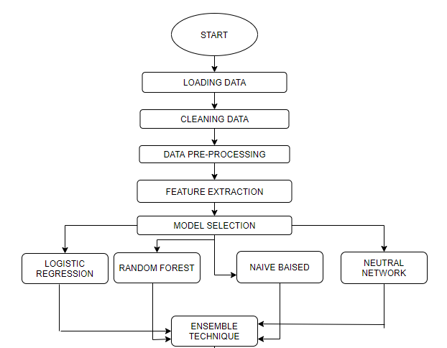

NAIVE BAYES

1. **DATA FLOW DIAGRAM**

8 (a) CONTEXT LEVEL DIAGRAM (DFD LEVEL 0)

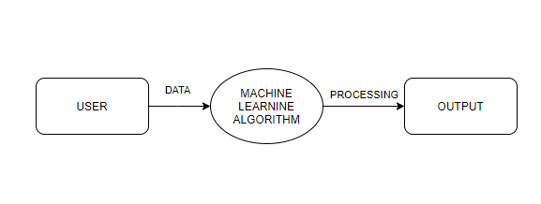

* The context level diagram (Data Flow Diagram Level 0) consist of two external entities the user interface & the output block.
* The machine learning algorithm represents the use of these algorithms such as logistic regression, random forest, naïve bayes & neural network.
* The output is obtained after processing.

1. (b) CONTEXT LEVEL DIAGRAM (DFD LEVEL 1)

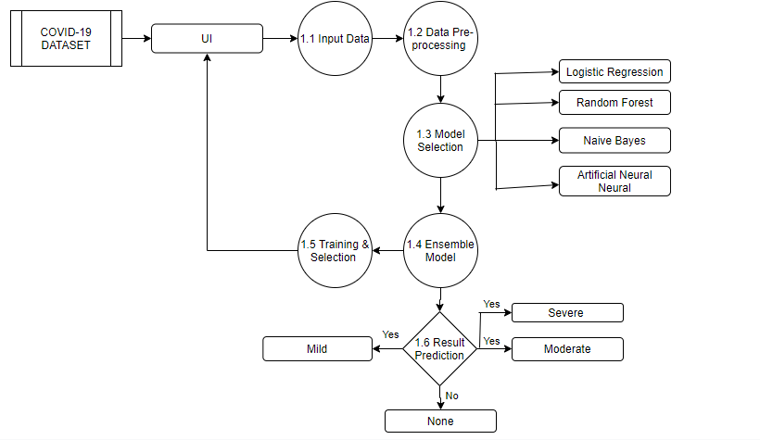

* The context diagram (DFD Level 1) contains 2 external entity UI block & Result Prediction block; five processes block Input data, Data Pre-processing, Model selection, Ensemble Model & Training and Selection block.
* The COVID-19 Dataset consists of text data that is downloaded from various sources.
* The UI interface inputs the data from the users .
* From 1.1 process block the data is being provided by the user.
* The next 1.2 block preprocess the data & for selecting the model 1.3 block works the machine learning algorithm.
* The next block 1.4 uses ensemble technique of bagging approach for final prediction of the data.
* The next block of 1.5 is used to train our machine learning model.
* Finally we get our results as per the given data.

1. **USE CASE DIAGRAM**

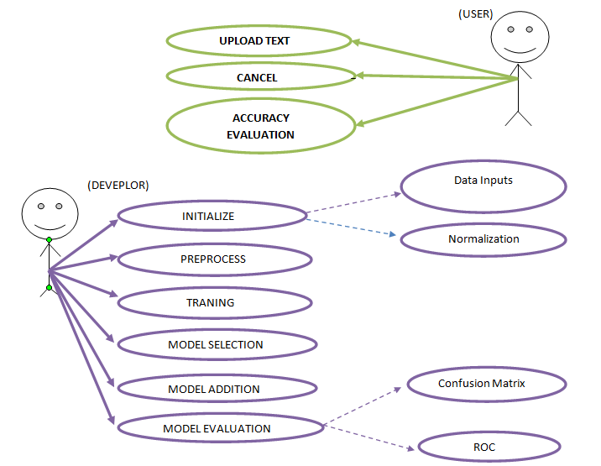

11. **NON FUNCTIONAL REQUIREMENT**

As the name suggest these are requirement that are not directly interacted with the specific function in this project.

* Performance: The symptoms are taken as input from the users and they are treated as the important feature for analysis.
* Availability: The results are only accurate if the features of the input provided by the users are true and correct.
* Flexibility: It provides the users very comfortable way to get symptoms from user interface and analysis them.
* Learn ability: The software is easy to use & reduced the learning work.

1. **DATASET**

* Data collection was an essential and protracted process. Regardless the field of research, accuracy of the data collection is essential to maintain cohesion.
* These data will help to identify whether any person is having COVID-19 or not based upon some pre-defined standard symptoms by World Health Organization (WHO) and Ministry of Health & Family Welfare, India.
* The data-set is a combined multi-dimensional data. It contains fields with textual data and some with precise values. The data set for COVID-19 symptoms have been downloaded from world health organization.
* The attributes that were considered in the data-set for the machine learning model are presented in Table 1.

|  |  |  |
| --- | --- | --- |
| **SR. No.** | **Feature Name** | **Feature Description** |
| 1 | Person Gender | The gender of a person |
| 2 | Person Age | Classification of age according to WHO age group standard |
| 3 | Country Visited | List of country a person has visited. |
| 4 | Symptoms | According to WHO there are tiredness, difficulty in breathing, dry cough, sore throat, pain, nasal congestion, runny nose, diarrhoea etc. |
| 5 | Severity | Levels of severity are mild, moderate & severe. |
| 6 | Contact | Has the person came in contacted with COVID-19 patient |

1. **SOFTWARE DESIGN**

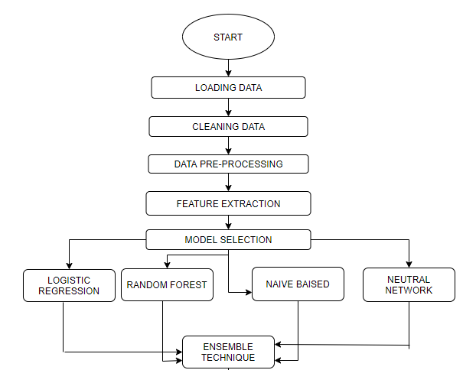

NAÏVE BAYES



1. **LOADING & CLEANING DATA**

The main reason behind data processing is that **data almost never comes in a form that is ready for us** and our personal experience, a large amount of time spent on a data science project is on manipulating data

.

* The dataset is being

.

* While loading our dataset we have raw, separate values (.csv files). Where we have 3,16,000 records on patients varying from different regions of the world.
* We have approximately twenty-five plus features which are acting as symptoms & we have to classify the data into four major categories based on our feature.
* We have binary data for each and every dependent & independent variables

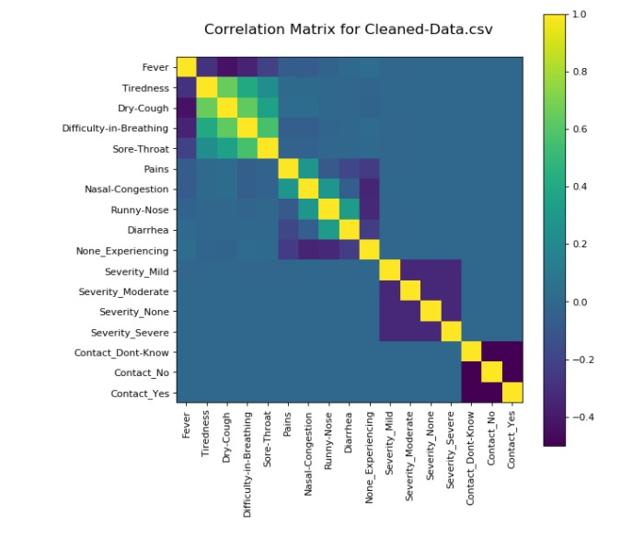

1. **DATA PRE-PROCESSING**

Data pre-processing occurs to be a curial step while implementing in every data science project. In our case due to binary data sight in every feature, we don’t require much pre-processing of our data.

* We have first tried to use feature engineering to handle our categorical data input. There are some null values after that we have gone for a basic dimensionally deduction by admitting the non reliable feature of the data.
* At last we have also gone through capturing feature i.e. very important for some analysis about the most relevant feature acting in our results.

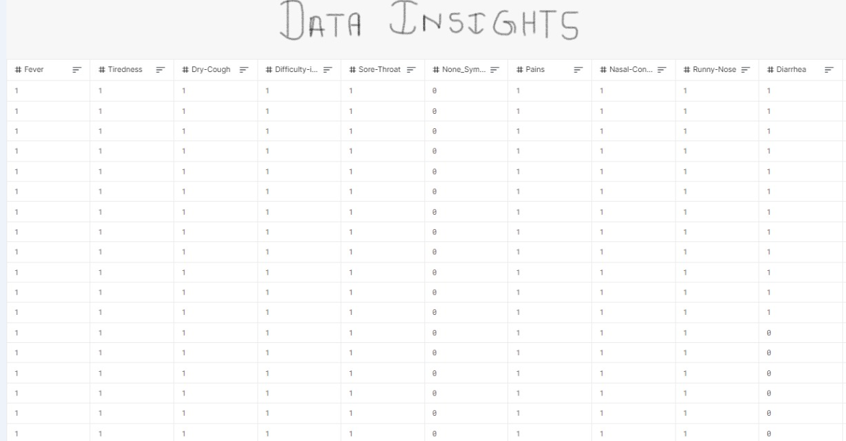

1. **MODEL SELECTION**

Due to the crucial medical condition we cannot rely completely on a single model. Hence we have to go for the ensemble technique which can help in adapting the result from different models and finally improve our result.

We have to use several machine learning algorithms such as logistic regression, random forest, naïve bayes & artificial neural network to create a model. This model will help to analyse & predict the final result using the bagging approach of the ensemble technique.

**16 (A) LOGISTIC REGRESSION ALGORITHM**

Logistic regression is a supervised learning classification algorithm used to predict the probability of a target variable. The nature of target or dependent variable is dichotomous, which means there would be only two possible classes.

In simple words, the dependent variable is binary in nature having data coded as either 1 (stands for success/yes) or 0 (stands for failure/no).

Mathematically, a logistic regression model predicts P(Y=1) as a function of X. It is one of the simplest ML algorithms that can be used for various classification problems such as spam detection, Diabetes prediction, cancer detection etc

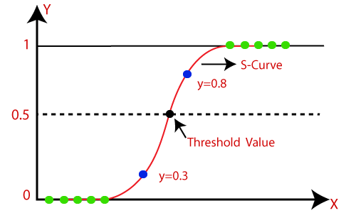

**16 (B) RANDOM FOREST ALGORITHM**

Random forest is a supervised learning algorithm which is used for both classification as well as regression. But however, it is mainly used for classification problems. As we know that a forest is made up of trees and more trees means more robust forest.

Similarly, random forest algorithm creates decision trees on data samples and then gets the prediction from each of them and finally selects the best solution by means of voting. It is an ensemble method which is better than a single decision tree because it reduces the over-fitting by averaging the result.

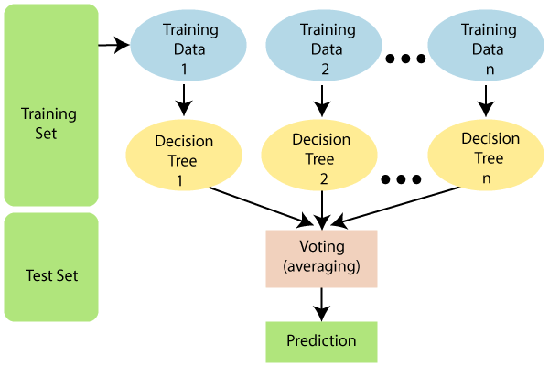

Implementation in Python

First, start with importing necessary Python packages −

import numpy as np

import matplotlib.pyplot as plt

import pandas as pd

**16 (C) NAIVE BAYES ALGORITHMS**

Naive Bayes algorithm is a classification technique based on applying Bayes’ theorem with a strong assumption that all the predictors are independent to each other. In simple words, the assumption is that the presence of a feature in a class is independent to the presence of any other feature in the same class.

In Bayesian classification, the main interest is to find the posterior probabilities i.e. the probability of a label given some observed features,

𝑃(𝐿 | 𝑓𝑒𝑎𝑡𝑢𝑟𝑒𝑠). With the help of Bayes theorem, we can express this in quantitative form as follows −

P(L|features)=P(L)P(features|L)P(features)P(L|features)=P(L)P(features|L)𝑃(𝑓𝑒𝑎𝑡𝑢𝑟𝑒𝑠)

Here, 𝑃(𝐿 | 𝑓𝑒𝑎𝑡𝑢𝑟𝑒𝑠) is the posterior probability of class.

𝑃(𝐿) is the prior probability of class.

𝑃(𝑓𝑒𝑎𝑡𝑢𝑟𝑒𝑠 | 𝐿) is the likelihood which is the probability of predictor given class.

𝑃(𝑓𝑒𝑎𝑡𝑢𝑟𝑒𝑠) is the prior probability of predictor.

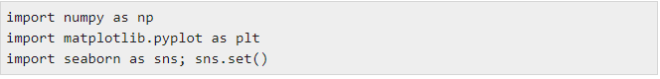

**16 (D) ARTIFICAIL NEURAL NETWORK ALGORITHM**

Artificial neural networks, usually simply called neural networks, are computing systems vaguely inspired by the biological neural networks that constitute animal brains. An ANN is based on a collection of connected units or nodes called artificial neurons, which loosely model the neurons in a biological brain.

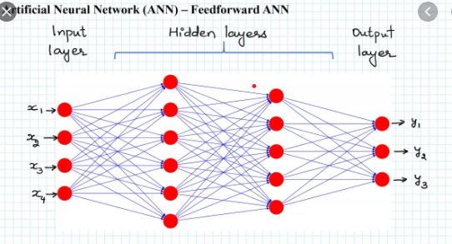

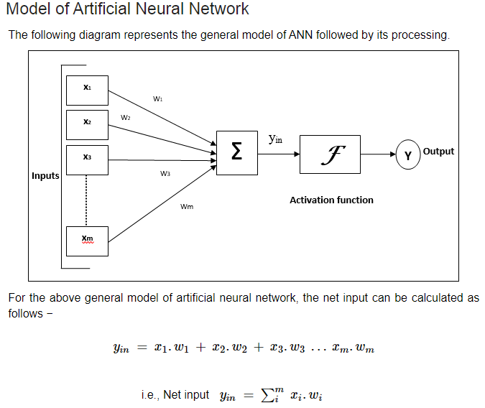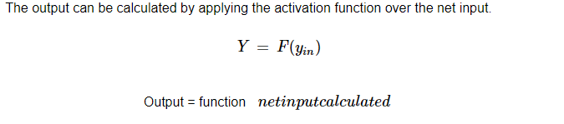

1. **ENSEMBLE TECHNIQUE**

* Ensemble technique is a machine learning techniquethat combines several base models in order to produce one optimal predictive model.
* In statistics and machine learning, ensemble methods use multiple learning algorithms to obtain better predictive performance than could be obtained from any of the constituent learning algorithms alone.

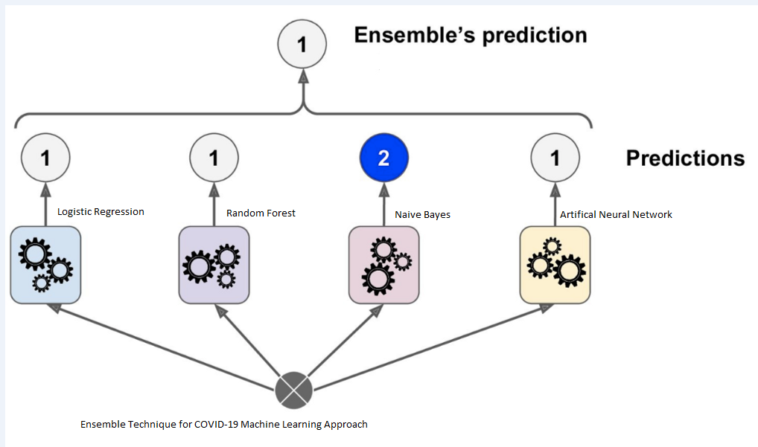

**Figure 1 shows the ensemble technique**

In the above figure ensemble technique is used to predict the result because multiple models are being used to get the result.

1. **PREDICTION & IMPLEMENTATION**

Finally after evaluating the final result came out by the bagging approach is very accurate we will get our predictable result .Our data is in the binary format so the values will be stored in the array.

Step I: Prepare to use Google Colab

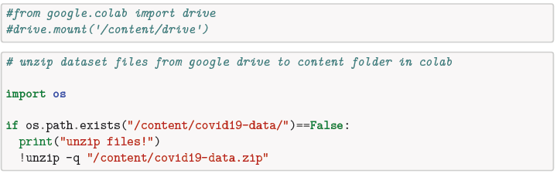

Step II: Import the data from library

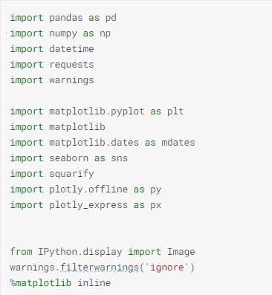

Step III: Read the datasets

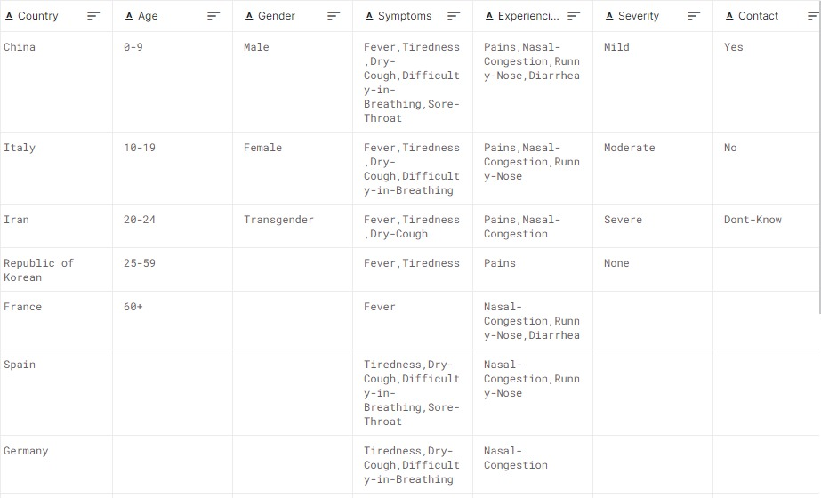

Step IV: Pre-process the data

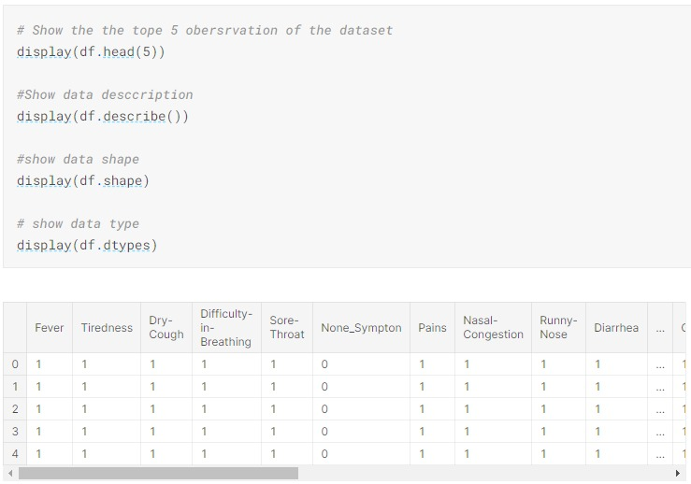

Step V: Analysis of Data

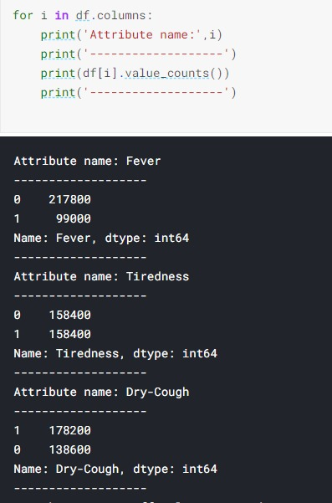

Step VI: Model Implementation

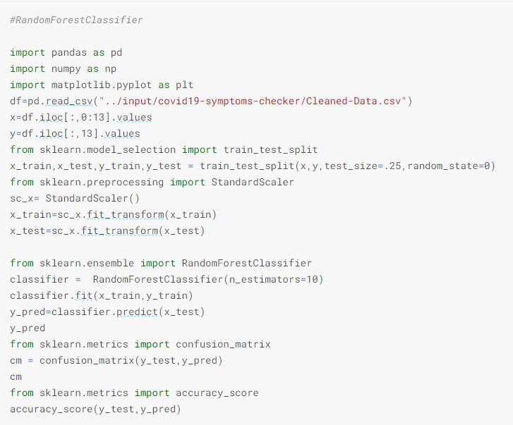

**19. LIMITATIONS**

* This entire project of COVID-19 is based upon the first wave of corona virus i.e. which can be determined by their symptoms.
* This project can only determine the result when the input values are correct.
* The machine learning model can be used to analysis the symptoms of this disease.
* To predict the actual result we have to use the clinical dataset which contains the patient medical reports such as CT scanning & RT-PCR test data.

**20. CONCLUSION**

* In this research, a systematic literature review has been conducted to identify the suitable algorithm for prediction of COVID-19 in patients.
* The selected algorithms were trained with the patient clinical information about the basic symptoms that indicated the infection in a person.

.

* A prediction system that could find the possibility of outbreak of novel diseases that could harm mankind through socio-economic and cultural factor consideration can be developed.
* It is recommended to work on calibrated and ensemble methods that could resolve problems faster with better outcomes than the existing algorithms

21. **REFERNCES**

[1] Punn, N. S, Sonbhadra, S. K. & Agarwal, S. COVID-19 Epidemic Analysis using Machine Learning and Deep Learning Algorithms. medRxiv, https://doi.org/10.1101/2020.04.08.20057679 (2020).

[2] Dong, E., Du, H. & Gardner, L. An interactive web-based dashboard to track COVID-19 in real time. Lancet Infect. Dis. <https://doi.org/10.1016/S1473-3099> (20)30120-1

[3] Mei, X. et al. Artificial intelligence–enabled rapid diagnosis of patients with

COVID-19. Nat. Med. 26, 1224–1228 (2020)

[4] Feng, C. et al. A novel triage tool of artificial intelligence assisted diagnosis aid system for suspected COVID-19 pneumonia in fever clinics. medRxiv, https://doi.org/10.1101/2020.03.19.20039099 (2020).

[5] Hastie, T., Tibshirani, R. & Friedman, J. In The Elements of Statistical Learning: Data

Mining, Inference, and Prediction (eds. Hastie, T.,Tibshirani, R. & Friedman, J.)337–387 (Springer, 2009).